**Search Page – Replace all Cyan Colour with site theme colour.**

**Quick Search Function**

**Replace buttons All – Explore (New buttons – Any, Casual, Something Serious,Friendship, Training,**

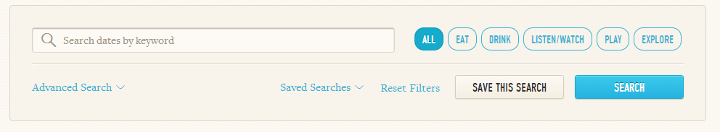

**Bottom left corner of box will say Advanced Search**

**Advanced Search**

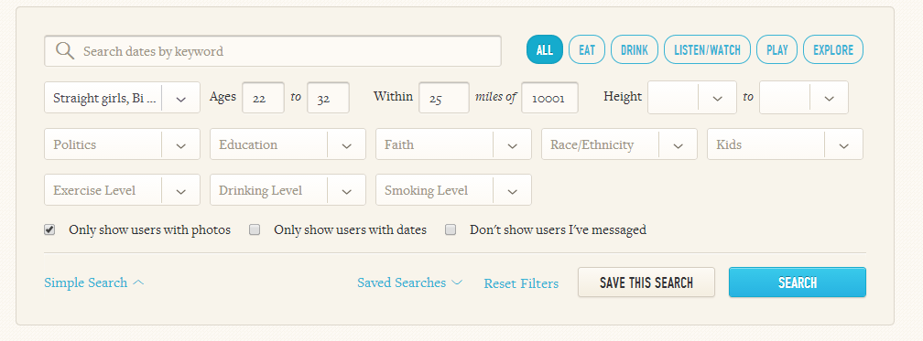

**change the search dates to a search interests by keyword**

**similar search function but get rid of politics filter, remove the none option from exercise filter**

**Remove the first two checkboxes at the bottom, keep the only to not show users that have previously been messages and add a checkbox to search only for verified users and a checkbox for online now**